**Blinkit Analysis**

* See all the data imported:

SELECT * FROM blinkit_data

* **DATA CLEANING:**

Cleaning the Item_Fat_Content field ensures data consistency and accuracy in analysis. The presence of multiple variations of the same category (e.g., LF, low fat vs. Low Fat) can cause issues in reporting, aggregations, and filtering. By standardizing these values, we improve data quality, making it easier to generate insights and maintain uniformity in our datasets.

UPDATE blinkit_data

SET Item_Fat_Content =

CASE

WHEN Item_Fat_Content IN ('LF', 'low fat') THEN 'Low Fat'

WHEN Item_Fat_Content = 'reg' THEN 'Regular'

ELSE Item_Fat_Content

END;

After executing this query check the data has been cleaned or not using below query

SELECT DISTINCT Item_Fat_Content FROM blinkit_data;

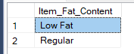

**A. KPI’s**

**1. TOTAL SALES:**

select round(sum(total_sales)/ 1000000 ,2) AS

Total_Sales_Million

FROM blinkit_data;

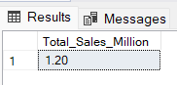

**2. AVERAGE SALES**

SELECT round(AVG(Total_Sales),0) AS Avg_Sales

FROM blinkit_data;

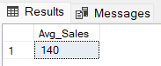

**3. NO OF ITEMS**

SELECT COUNT(*) AS No_of_Orders

FROM blinkit_data;

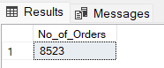

**4. AVG RATING**

SELECT CAST(AVG(Rating) AS DECIMAL(10,1)) AS Avg_Rating

FROM blinkit_data;

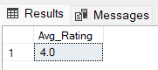

**B. Total Sales by Fat Content:**

SELECT Item_Fat_Content, CAST(SUM(Total_Sales) AS DECIMAL(10,2)) AS Total_Sales

FROM blinkit_data

GROUP BY Item_Fat_Content

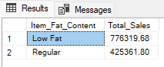

**C. Total Sales by Item Type**

SELECT Item_Type, CAST(SUM(Total_Sales) AS DECIMAL(10,2)) AS Total_Sales

FROM blinkit_data

GROUP BY Item_Type

ORDER BY Total_Sales DESC

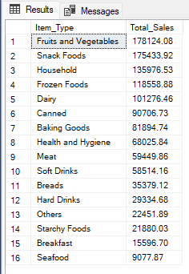

**D. Fat Content by Outlet for Total Sales**

SELECT Outlet_Location_Type,

ISNULL([Low Fat], 0) AS Low_Fat,

ISNULL([Regular], 0) AS Regular

FROM

(

SELECT Outlet_Location_Type, Item_Fat_Content,

CAST(SUM(Total_Sales) AS DECIMAL(10,2)) AS Total_Sales

FROM blinkit_data

GROUP BY Outlet_Location_Type, Item_Fat_Content

) AS SourceTable

PIVOT

(

SUM(Total_Sales)

FOR Item_Fat_Content IN ([Low Fat], [Regular])

) AS PivotTable

ORDER BY Outlet_Location_Type;

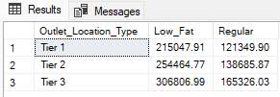

**Query Explanations**

This query aims to transform the blinkit_data table to display total sales (Total_Sales) for each combination of Outlet_Location_Type and Item_Fat_Content. The result will show Outlet_Location_Type as rows and Item_Fat_Content categories ("Low Fat" and "Regular") as columns. If there are no sales for a particular combination, the query will display 0 instead of NULL.

**Detailed Explanation:**

1. **Subquery**
   * **Aggregation:**

*sql*

*CopyEdit*

*SELECT*

*Outlet_Location_Type,*

*Item_Fat_Content,*

*CAST(SUM(Total_Sales) AS DECIMAL(10,2)) AS Total_Sales*

*FROM*

*blinkit_data*

*GROUP BY*

*Outlet_Location_Type,*

*Item_Fat_Content*

* + - **Purpose:** This subquery groups the data by Outlet_Location_Type and Item_Fat_Content, calculating the total sales for each combination.
    - **CAST(SUM(Total_Sales) AS DECIMAL(10,2)):** Sums the Total_Sales for each group and casts the result to a decimal with two decimal places for precision.

1. **PIVOT Operation:**
   * **Pivoting:**

*sql*

*CopyEdit*

*PIVOT*

*(*

*SUM(Total_Sales)*

*FOR Item_Fat_Content IN ([Low Fat], [Regular])*

*) AS PivotTable*

* + - **Purpose:** Transforms the rows of Item_Fat_Content into columns ([Low Fat] and [Regular]).
    - **SUM(Total_Sales):** Aggregates the Total_Sales for each Item_Fat_Content category within each Outlet_Location_Type.

1. **Main Query:**
   * **Selecting and Handling NULLs:**

*sql*

*CopyEdit*

*SELECT*

*Outlet_Location_Type,*

*ISNULL([Low Fat], 0) AS Low_Fat,*

*ISNULL([Regular], 0) AS Regular*

*FROM*

*PivotTable*

*ORDER BY*

*Outlet_Location_Type;*

* + - **ISNULL([Low Fat], 0) AS Low_Fat:** Replaces any NULL values in the [Low Fat] column with 0 and renames the column to Low_Fat.
    - **ISNULL([Regular], 0) AS Regular:** Similarly, replaces NULL values in the [Regular] column with 0.
    - **ORDER BY Outlet_Location_Type:** Sorts the final result set by Outlet_Location_Type.

**Why Use ISNULL?**

When performing a PIVOT operation, if a particular combination of Outlet_Location_Type and Item_Fat_Content doesn't exist in the data, the resulting cell will contain a NULL value. Using ISNULL(column)

**E. Total Sales by Outlet Establishment**

SELECT Outlet_Establishment_Year, CAST(SUM(Total_Sales) AS DECIMAL(10,2)) AS Total_Sales

FROM blinkit_data

GROUP BY Outlet_Establishment_Year

ORDER BY Outlet_Establishment_Year

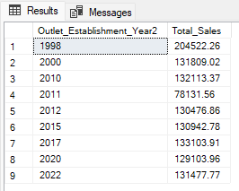

**F. Percentage of Sales by Outlet Size**

SELECT

Outlet_Size,

CAST(SUM(Total_Sales) AS DECIMAL(10,2)) AS Total_Sales,

CAST((SUM(Total_Sales) * 100.0 / SUM(SUM(Total_Sales)) OVER()) AS DECIMAL(10,2)) AS Sales_Percentage

FROM blinkit_data

GROUP BY Outlet_Size

ORDER BY Total_Sales DESC;

**Query Explanation:**

**Outlet_Size**: This column represents the size category of the outlet (e.g., Small, Medium, Large).

**CAST(SUM(Total_Sales) AS DECIMAL(10,2)) AS Total_Sales**:

* **SUM(Total_Sales)**: Calculates the total sales for each Outlet_Size.
* **CAST(... AS DECIMAL(10,2))**: Formats the resulting sum to a decimal number with two decimal places for precision.

**CAST((SUM(Total_Sales) * 100.0 / SUM(SUM(Total_Sales)) OVER()) AS DECIMAL(10,2)) AS Sales_Percentage**:

* **SUM(Total_Sales) * 100.0**: Multiplies the total sales of the current Outlet_Size by 100 to prepare for percentage calculation.
* **SUM(SUM(Total_Sales)) OVER()**:
  + **SUM(Total_Sales)**: Within the GROUP BY context, this computes the total sales for each Outlet_Size.
  + **SUM(... ) OVER()**: The outer SUM combined with the OVER() clause calculates the grand total of all Total_Sales across all outlet sizes without collapsing the result set.
* **SUM(Total_Sales) * 100.0 / SUM(SUM(Total_Sales)) OVER()**: Divides the total sales of the current Outlet_Size by the grand total sales and multiplies by 100 to get the percentage contribution of each outlet size to the overall sales.
* **CAST(... AS DECIMAL(10,2))**: Formats the resulting percentage to two decimal places.

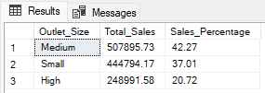

**G. Sales by Outlet Location**

SELECT Outlet_Location_Type, CAST(SUM(Total_Sales) AS DECIMAL(10,2)) AS Total_Sales

FROM blinkit_data

GROUP BY Outlet_Location_Type

ORDER BY Total_Sales DESC

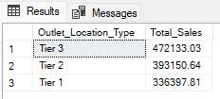

**H. All Metrics by Outlet Type:**

SELECT Outlet_Type,

CAST(SUM(Total_Sales) AS DECIMAL(10,2)) AS Total_Sales,

CAST(AVG(Total_Sales) AS DECIMAL(10,0)) AS Avg_Sales,

COUNT(*) AS No_Of_Items,

CAST(AVG(Rating) AS DECIMAL(10,2)) AS Avg_Rating,

CAST(AVG(Item_Visibility) AS DECIMAL(10,2)) AS Item_Visibility

FROM blinkit_data

GROUP BY Outlet_Type

ORDER BY Total_Sales DESC

